**Batch: A1 Roll No.: 1911012 , 1911014**

**Experiment / assignment / tutorial No.**

**Grade: AA / AB / BB / BC / CC / CD /DD**

**Signature of the Staff In-charge with date**

|  |
| --- |
| **Title: Python Application Development** |

**AIM :** To develop a python application for a real world problem

**______________________________________________________________________**

**Expected OUTCOME of Experiment:**

**CO :**

**________________________________________________________________**

**Books/ Journals/ Websites referred:**

* <https://docs.python.org/3/library/tkinter.html>
* <https://www.python-course.eu/>
* <https://stackoverflow.com/questions>
* <https://www.tutorialspoint.com/python/>
* <https://www.geeksforgeeks.org/python-gui-tkinter/>
* <https://www.javatpoint.com/sqlite-tutorial>
* <https://www.sqlite.org/index.html>

**Github Link of Project files :**

<https://github.com/Patrickbro13/Store-management-system>

**Problem definition:**

* Store management System is a desktop application that enables store owner to keep track of all of the products present in the store and also to handle the bills.
* It also provides a platform to update the stock and keep a track on the stocks sold.
* It also helps to maintain the money record of all the profits made buy the store

**Scope:**

* User can easily add products to the database
* User can generate bills.
* The bills get automatically printed and saved.
* The stock of products gets updated according to the quantity of the products sold.
* The user gets notification for less stock of products in the store.
* The user can give discounts to the special customers.
* The user can easily calculate the change amount according the bill amount and the sum paid by the customer**.**

**Component diagram:**

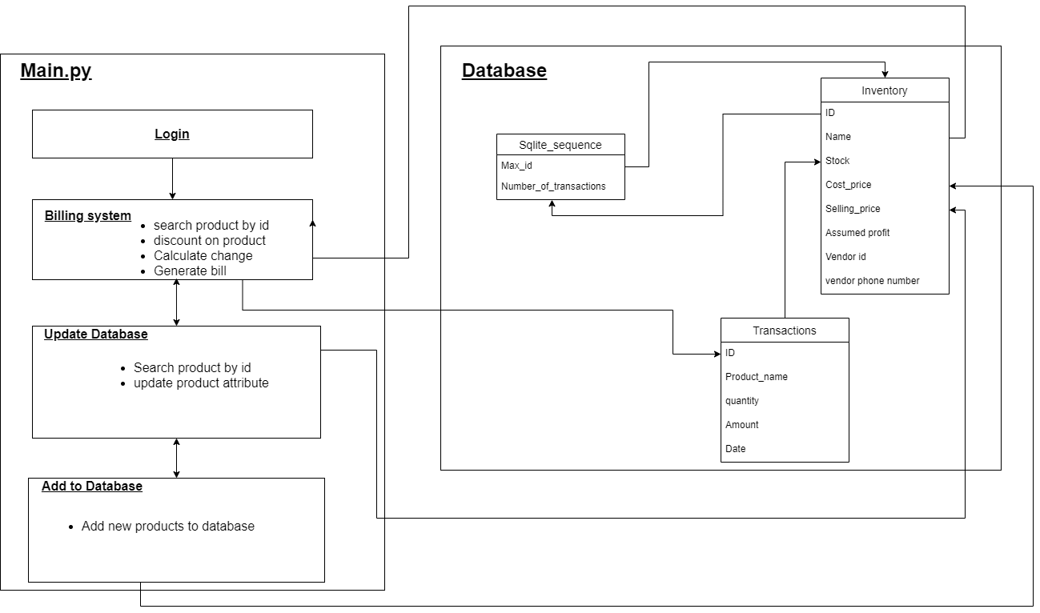

**API or packages used:**

* Tkinter module
  + Message box
  + Combo box
  + Frame navigations
* re module
  + Regular expressions for checking phone number
* Sqlite3 module
  + Database connectivity and Query handling
* datetime module
  + To show the current date and to create subfolders for bills with respect to current date

**Difficulties faced and measures taken to resolve:**

1. **Frame navigations :**

Initially we were following a Object oriented approach, since we had different frames such as landing frame, update database frame, add to database frame. So for simplicity we had created different py files for each frame . But when it came to import this frames in one single frame all frames were getting loaded on screen instead of just a landing frame. Then we looked for a lot of solutions on stack overflow and google but in many of the cases those users had created all all the frames in a single file and then using frame.tkraise() they were displaying the required frame. So we also taken all our code from OOP approach to a procedural programming approach where we divided our whole into 4 parts of our frames added the code accordingly.

1. **Database connectivity**

Since we are using sqlite3 database, we were connecting to database using sqlite3.connect() method where as a parameter we were passing a relative path of the database file but it was giving an error that path or directory does not exists but it was working fine when full path was given. So user would have to enter his path of that database in his local machine into the path variable which we had created, so to avoid this using os.getcwd() method of os library we obtained the path of current directory and then from that directory we appended our database path so now user won’t need to specify his database path directly as we have already done that using os.getcwd() method .

1. **Combo box default value**

For a store manager , while entering a ID to get the amount of the product given by user we had added a dropdown using Combo box in tkinter which will show the store manager all the products with their ID’s . While doing so we had added a default value ‘product list’ on that combobox so that store manager will get to know that , this is where he can see the all products with their ID’s but it was not showing a default value which we had assigned using Combobox.current(0) So from google we tried some other methods such as StringVal(value=’default’) and Combobox.place(default=”defaultvalue”) but this methods were also not working so we decided to add a label in front of the Combo box that will tell user that here is the product list .

1. **Dynamic ID updation**

As we have implemented a feature of adding new products to database, while adding new products to database we had shown the user how many products are already there in database so after adding new products that number of products should get updated. But even after adding that number was not getting updated so added another lines of code which will Label.configure()

Method so the text of that label after adding new data into database will get increamented

1. **Printing bills**

In our program we had added a feature of storing and printing bill in a bills folder. When the user was pressing a generate bill button the bill was not getting stored. So we tried to debug that part and we found out that again the path problem was occurring so we had to again put the full path of the directory but again so we don’t have to make user add his path of that folder from his machine to the code we used os.getcwd() method of os library and obtained a path for current directory and appended a path to the bill directory after which the bills were getting stored properly.

**Team work (Contribution of each member).**

|  |  |
| --- | --- |
| **Work** | **Student Name** |
| **Frontend** | **Rushabh Gandhi & Pathik Ghugare.** |
| **UI Design** | **Rushabh Gandhi & Pathik Ghugare.** |
| **Database Design** | **Rushabh Gandhi** |
| **Database connectivity & query handling** | **Rushabh Gandhi** |
| **Creation of frames** | **Pathik Ghugare** |
| **Adding functionality to frames** | **Pathik Ghugare** |
| **Dynamic calculation of prices** | **Rushabh Gandhi** |
| **Managing the bills** | **Rushabh Gandhi** |
| **Exception handling** | **Pathik Ghugare** |
| **Added product list view** | **Rushabh Gandhi & Pathik Ghugare.** |